**PROGRAM:**

**package** meena;

**public** **class** Student18 **implements** Cloneable {

**int** rollno;

String name;

Student18(**int** rollno,String name){

**this**.rollno=rollno;

**this**.name=name;

}

**public** Object clone()**throws** CloneNotSupportedException{

**return** **super**.clone();

}

**public** **static** **void** main(String args[]){

**try**{

Student18 s1=**new** Student18(101,"meena");

Student18 s2=(Student18)s1.clone();

System.***out***.println(s1.rollno+" "+s1.name);

System.***out***.println(s2.rollno+" "+s2.name);

}**catch**(CloneNotSupportedException c){}

}

}

**OUTPUT:**

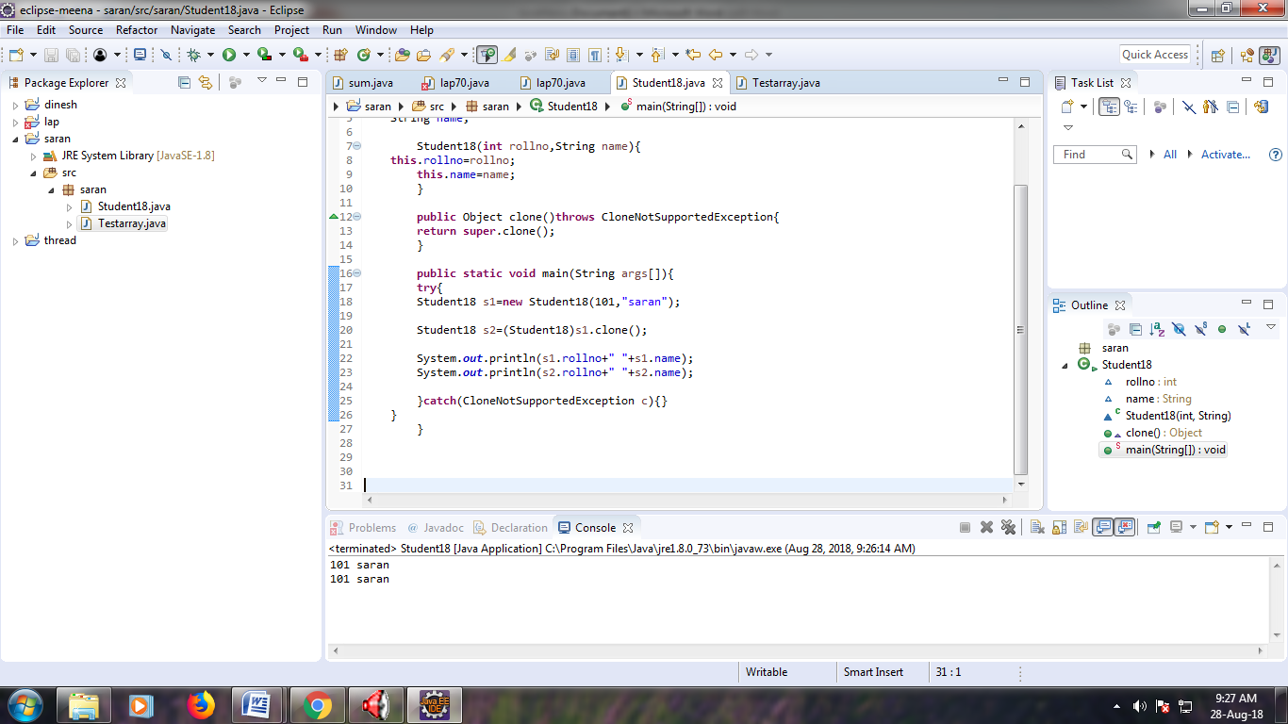

**PROGRAM:**

**package** meena;

**public** **class** Testarray {

**public** **static** **void** main(String args[]){

**int** a[]=**new** **int**[5];//declaration and instantiation

a[0]=10;//initialization

a[1]=20;

a[2]=70;

a[3]=40;

a[4]=50;

//printing array

**for**(**int** i=0;i<a.length;i++)//length is the property of array

System.***out***.println(a[i]);

}}

**OUTPUT:**

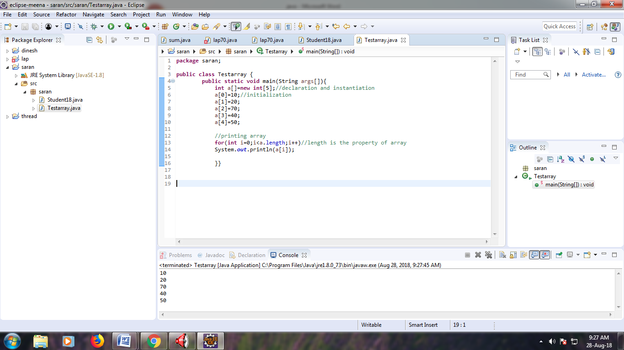

**PROGRAM:**

**package** meena;

**public** **class** Testarray2 {

**static** **void** min(**int** arr[]){

**int** min=arr[0];

**for**(**int** i=1;i<arr.length;i++)

**if**(min>arr[i])

min=arr[i];

System.***out***.println(min);

}

**public** **static** **void** main(String args[]){

**int** a[]={33,3,4,5};

*min*(a);//passing array to method

}}

**OUTPUT:**

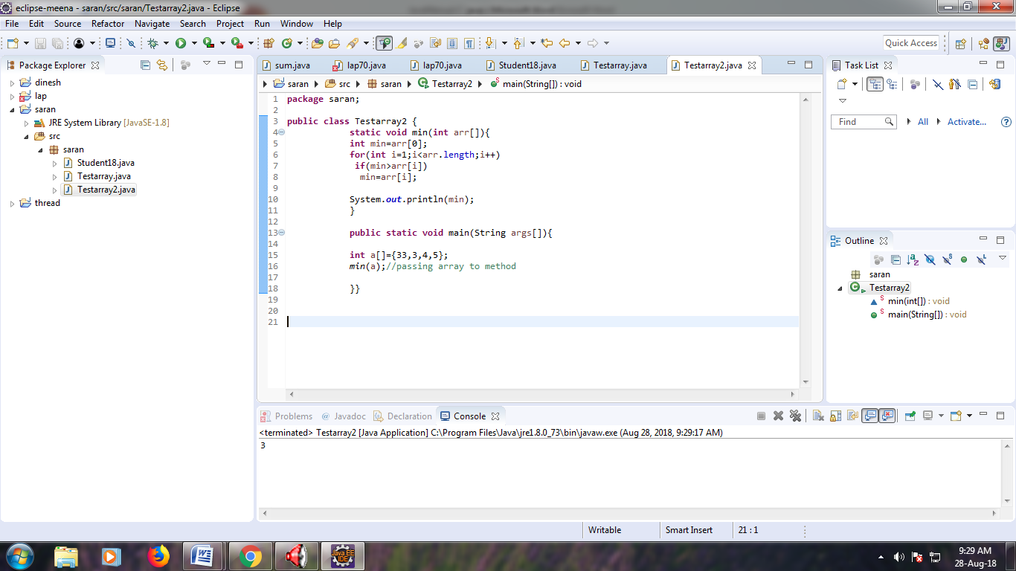

**PROGRAM:**

**package** meena;

**public** **class** Testarray3 {

**public** **static** **void** main(String args[]){

//declaring and initializing 2D array

**int** arr[][]={{1,2,3},{2,4,5},{4,4,5}};

//printing 2D array

**for**(**int** i=0;i<3;i++){

**for**(**int** j=0;j<3;j++){

System.***out***.print(arr[i][j]+" ");

}

System.***out***.println();

}

}}

**OUTPUT:**

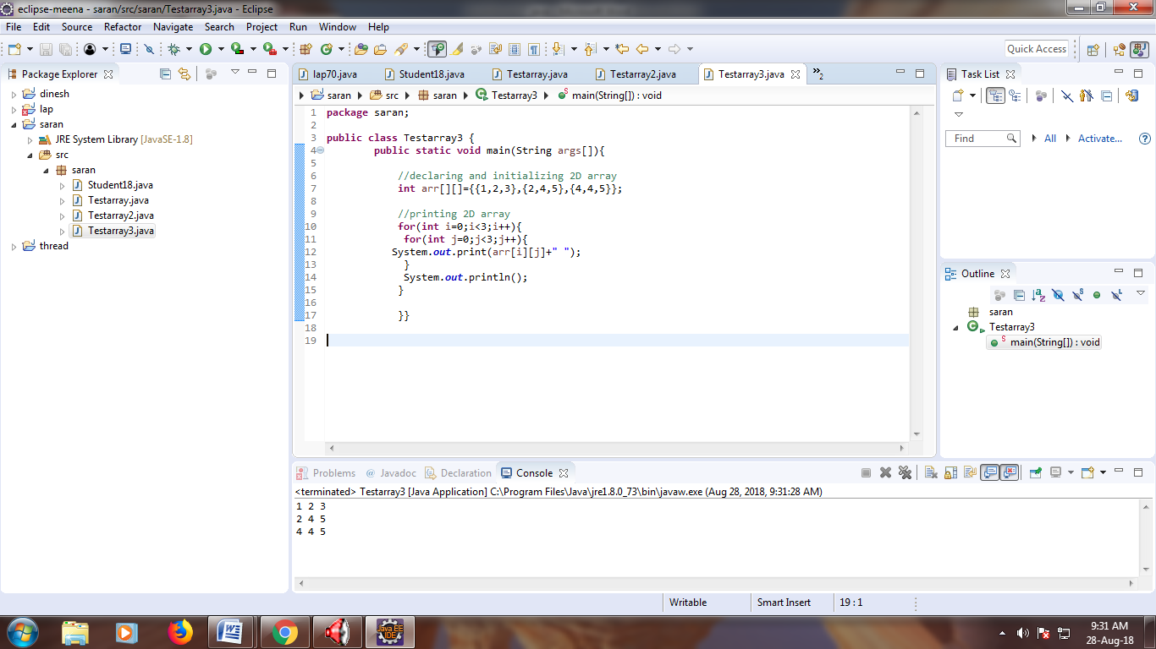

**PROGRAM:**

**package** meena;

**public** **class** TestarrayCopyDemo {

**public** **static** **void** main(String[] args) {

**char**[] copyFrom = { 'd', 'e', 'c', 'a', 'f', 'f', 'e',

'i', 'n', 'a', 't', 'e', 'd' };

**char**[] copyTo = **new** **char**[7];

System.*arraycopy*(copyFrom, 2, copyTo, 0, 7);

System.***out***.println(**new** String(copyTo));

}

}

**OUTPUT:**

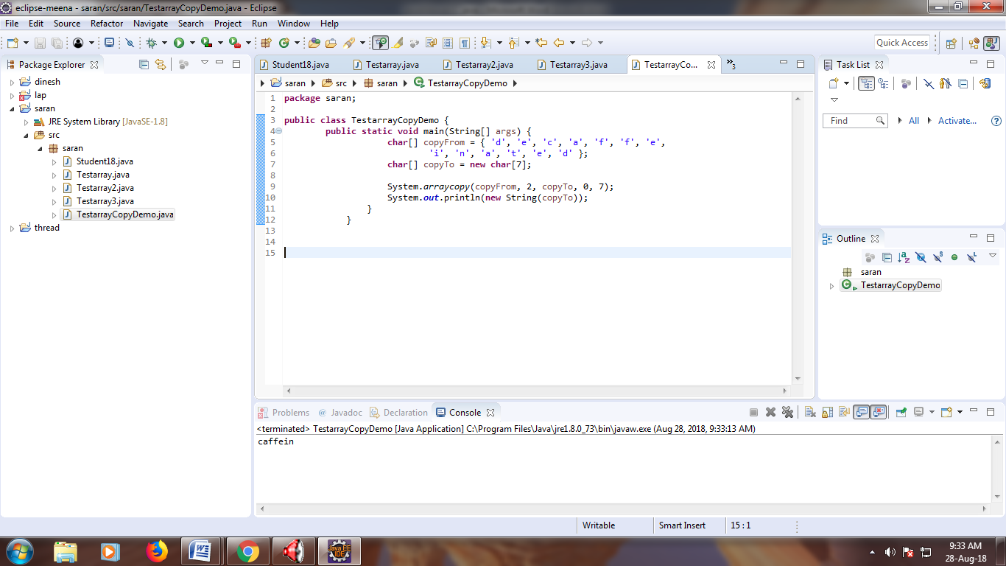

**PROGRAM:**

**package** meena;

**public** **class** Testarray5 {

**public** **static** **void** main(String args[]){

//creating two matrices

**int** a[][]={{1,3,4},{3,4,5}};

**int** b[][]={{1,3,4},{3,4,5}};

//creating another matrix to store the sum of two matrices

**int** c[][]=**new** **int**[2][3];

//adding and printing addition of 2 matrices

**for**(**int** i=0;i<2;i++){

**for**(**int** j=0;j<3;j++){

c[i][j]=a[i][j]+b[i][j];

System.***out***.print(c[i][j]+" ");

}

System.***out***.println();//new line

}

}}

**OUTPUT:**

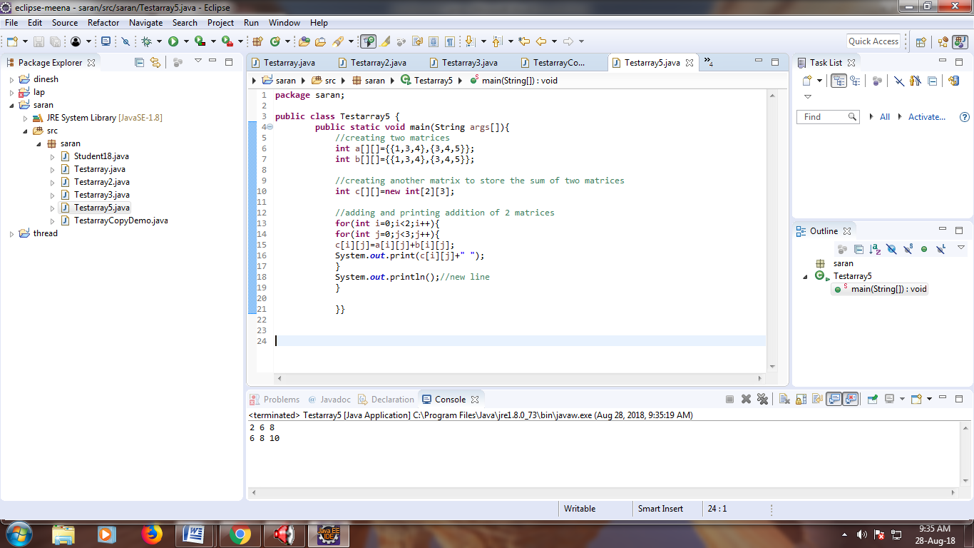

**PROGRAM:**

**package** meena;

**public** **class** WrapperExample1 {

**public** **static** **void** main(String args[]){

//Converting int into Integer

**int** a=20;

Integer i=Integer.*valueOf*(a);//converting int into Integer

Integer j=a;//autoboxing, now compiler will write Integer.valueOf(a) internally

System.***out***.println(a+" "+i+" "+j);

}}

**OUTPUT:**

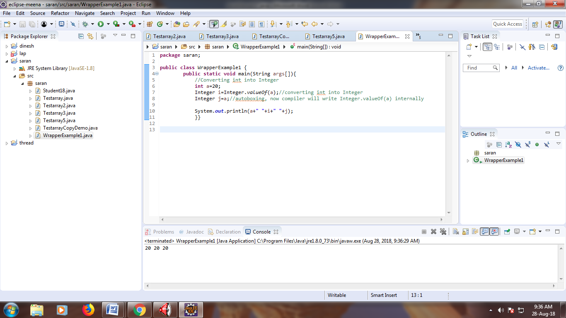

**PROGRAM:**

**package** meena;

**public** **class** WrapperExample2 {

**public** **static** **void** main(String args[]){

//Converting Integer to int

Integer a=**new** Integer(3);

**int** i=a.intValue();//converting Integer to int

**int** j=a;//unboxing, now compiler will write a.intValue() internally

System.***out***.println(a+" "+i+" "+j);

}}

**OUTPUT:**

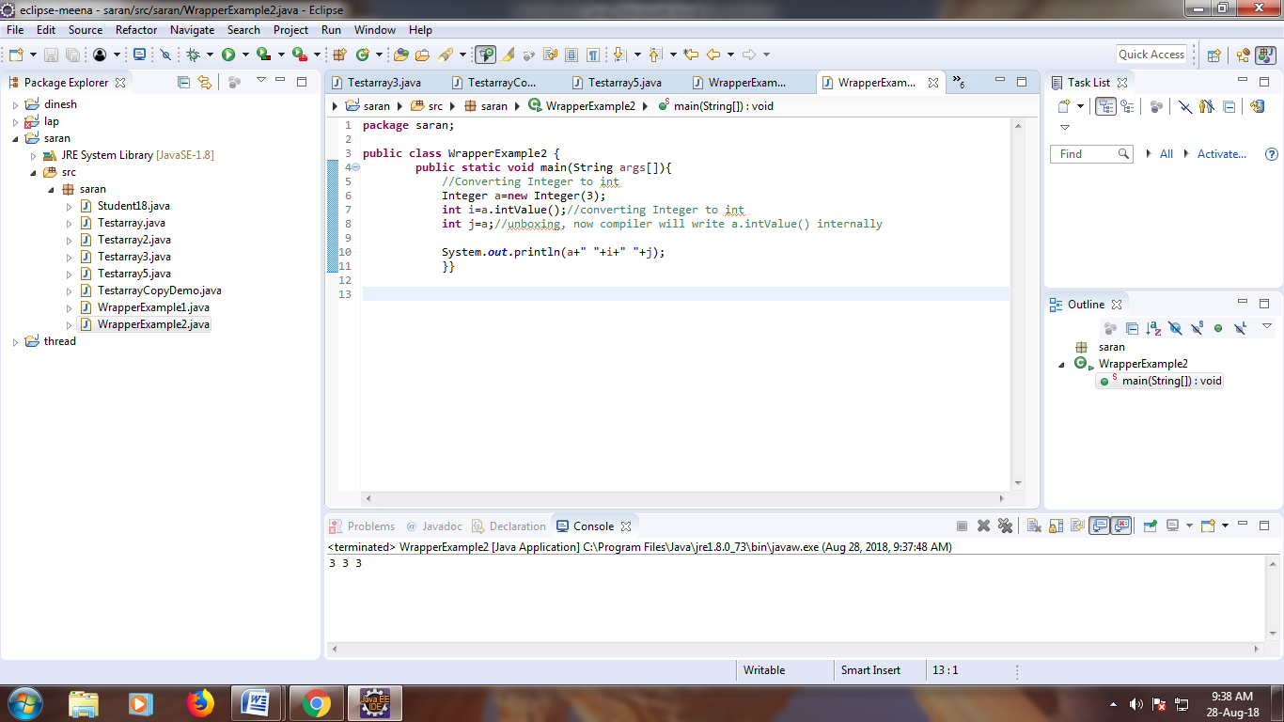

**PROGRAM:**

**package** meena;

**public** **class** Operation {

**int** data=50;

**void** change(**int** data){

data=data+100;//changes will be in the local variable only

}

**public** **static** **void** main(String args[]){

Operation op=**new** Operation();

System.***out***.println("before change "+op.data);

op.change(500);

System.***out***.println("after change "+op.data);

}

}

**OUTPUT:**

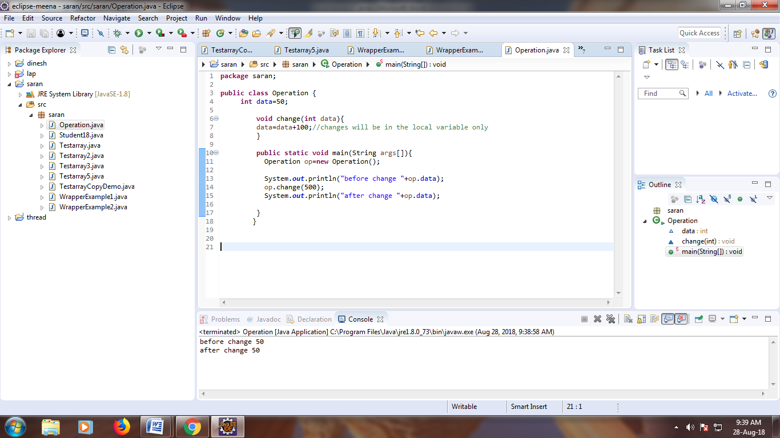

Ex65:

**PROGRAM:**

**package** meena;

**public** **class** StringExample {

**public** **static** **void** main(String args[]){

String s1="java";//creating string by java string literal

**char** ch[]={'s','a','r','a','n','y','a'};

String s2=**new** String(ch);//converting char array to string

String s3=**new** String("hello");

System.***out***.println(s1);

System.***out***.println(s2);

System.***out***.println(s3);

}}

**OUTPUT:**

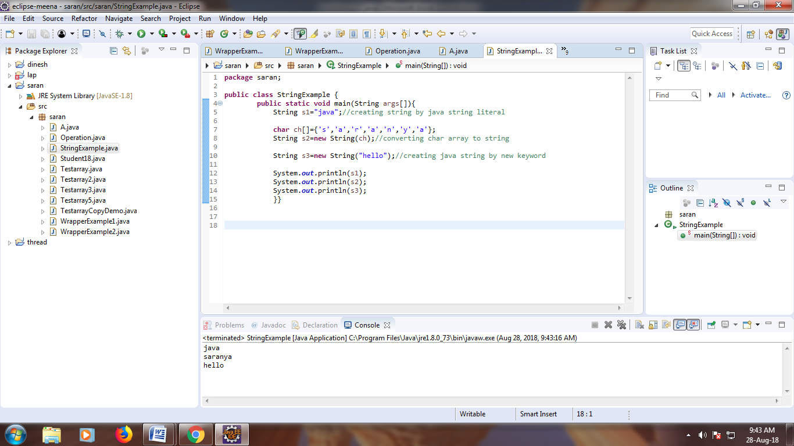

**PROGRAM:**

**package** meena;

**public** **class** Testimmutablestring {

**public** **static** **void** main(String args[]){

String s="mahendra singh";

s.concat(" dhoni");//concat() method appends the string at the end

System.***out***.println(s);//will print mahendra singh because strings are immutable object

}

}

**OUTPUT:**

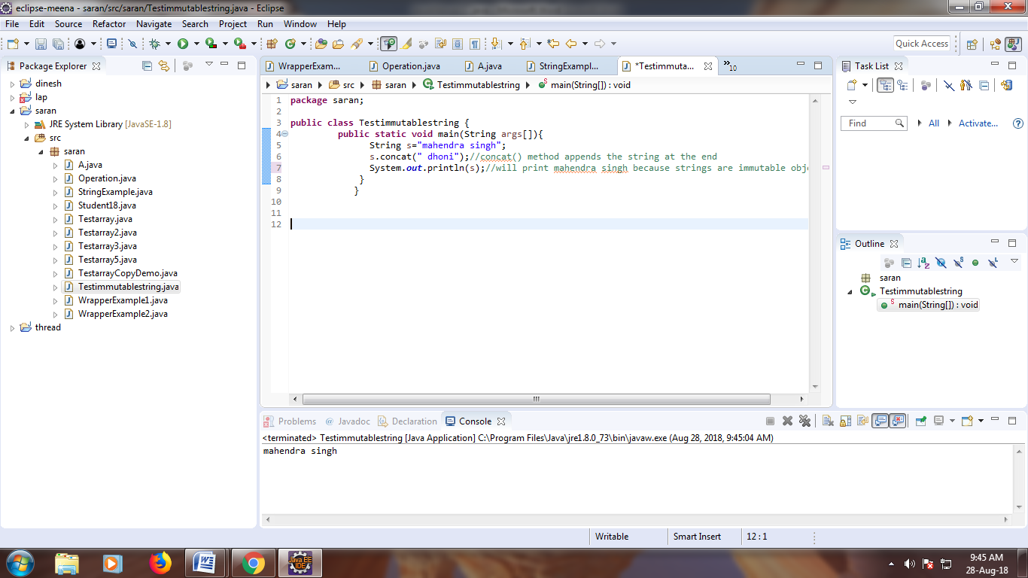

**PROGRAM:**

**package** meena;

**public** **class** Teststringcomparison1 {

**public** **static** **void** main(String args[]){

String s1="Sachin";

String s2="Sachin";

String s3=**new** String("Sachin");

String s4="Saurav";

System.***out***.println(s1.equals(s2));//true

System.***out***.println(s1.equals(s3));//true

System.***out***.println(s1.equals(s4));//false

}

}

**OUTPUT:**

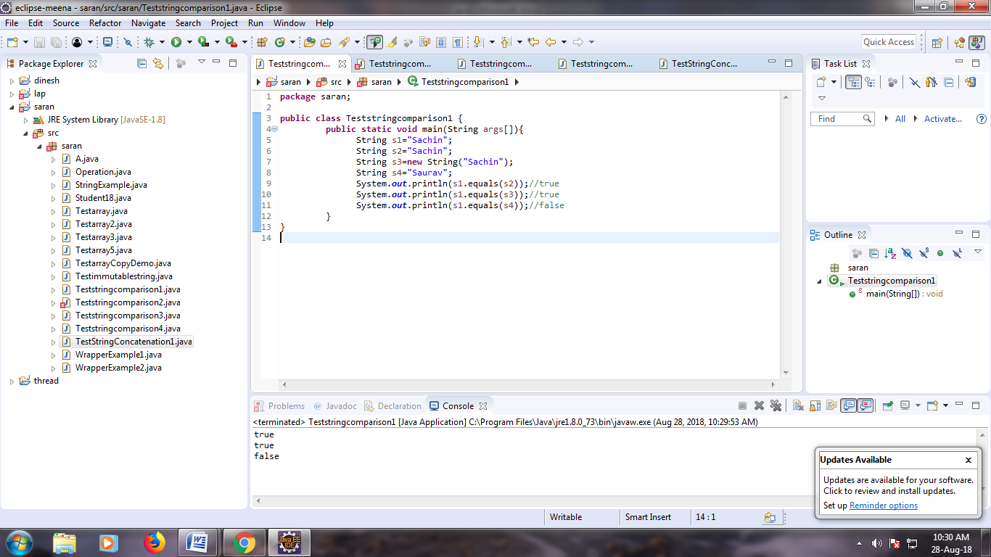

**PROGRAM:**

**package** meena;

**public** **class** Teststringcomparison3 {

**public** **static** **void** main(String args[]){

String s1="Sachin";

String s2="Sachin";

String s3=**new** String("Sachin");

System.***out***.println(s1==s2);//true (because both refer to same instance)

System.***out***.println(s1==s3);//false(because s3 refers to instance created in nonpool)

}

}

**OUTPUT:**

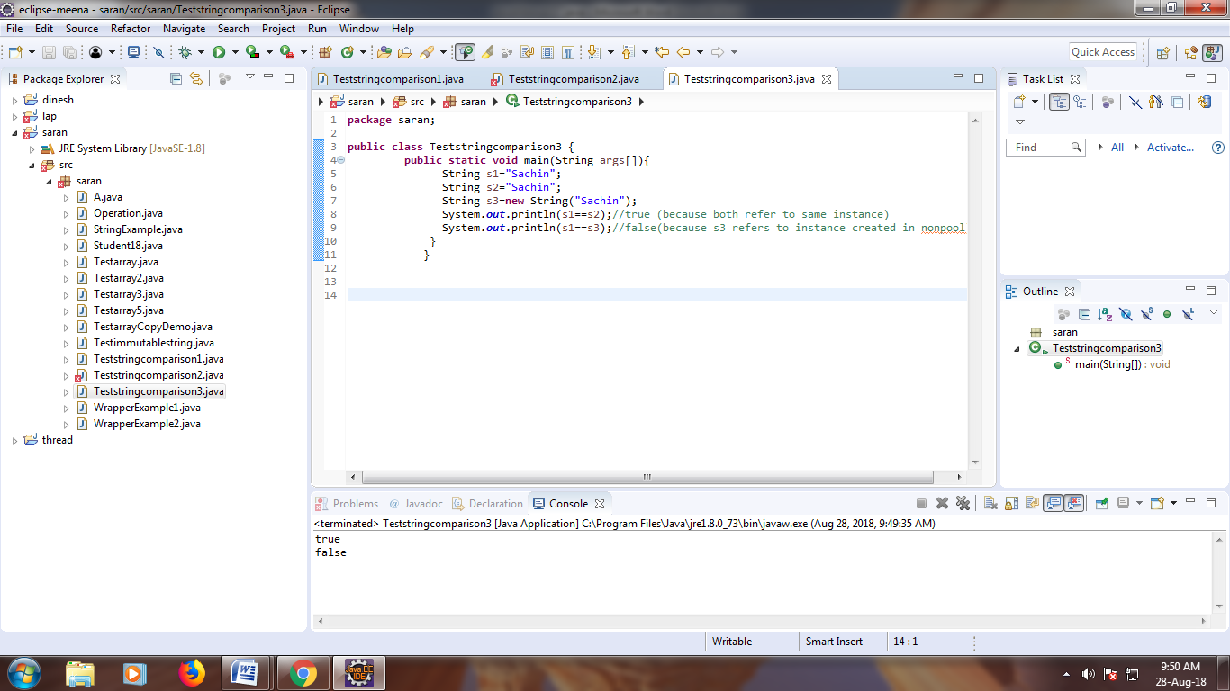

**PROGRAM:**

**package** meena;

**public** **class** Teststringcomparison4 {

**public** **static** **void** main(String args[]){

String s1="Sachin";

String s2="Sachin";

String s3="Ratan";

System.***out***.println(s1.compareTo(s2));//0

System.***out***.println(s1.compareTo(s3));//1(because s1>s3)

System.***out***.println(s3.compareTo(s1));//-1(because s3 < s1 )

}

}

**OUTPUT:**

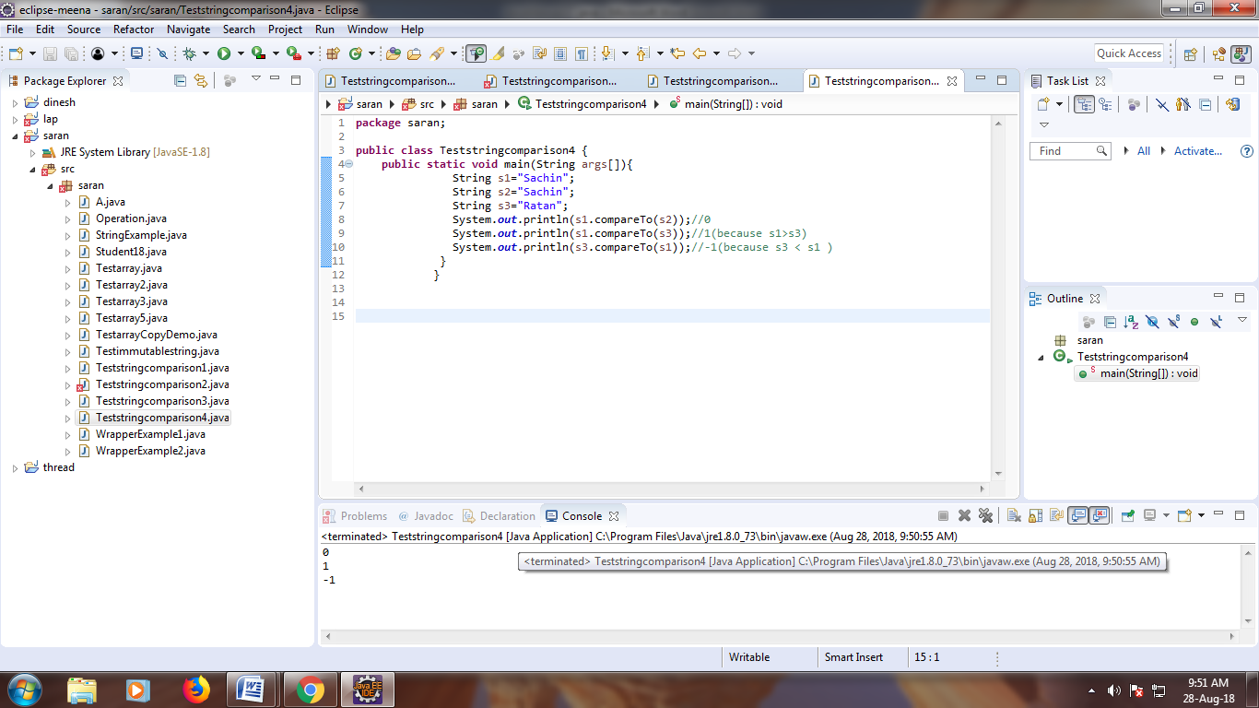

**PROGRAM:**

**package** meena;

**public** **class** TestStringConcatenation1 {

**public** **static** **void** main(String args[]){

String s="virat"+" kohli";

System.***out***.println(s);//Sachin Tendulkar

}

}

**OUTPUT:**

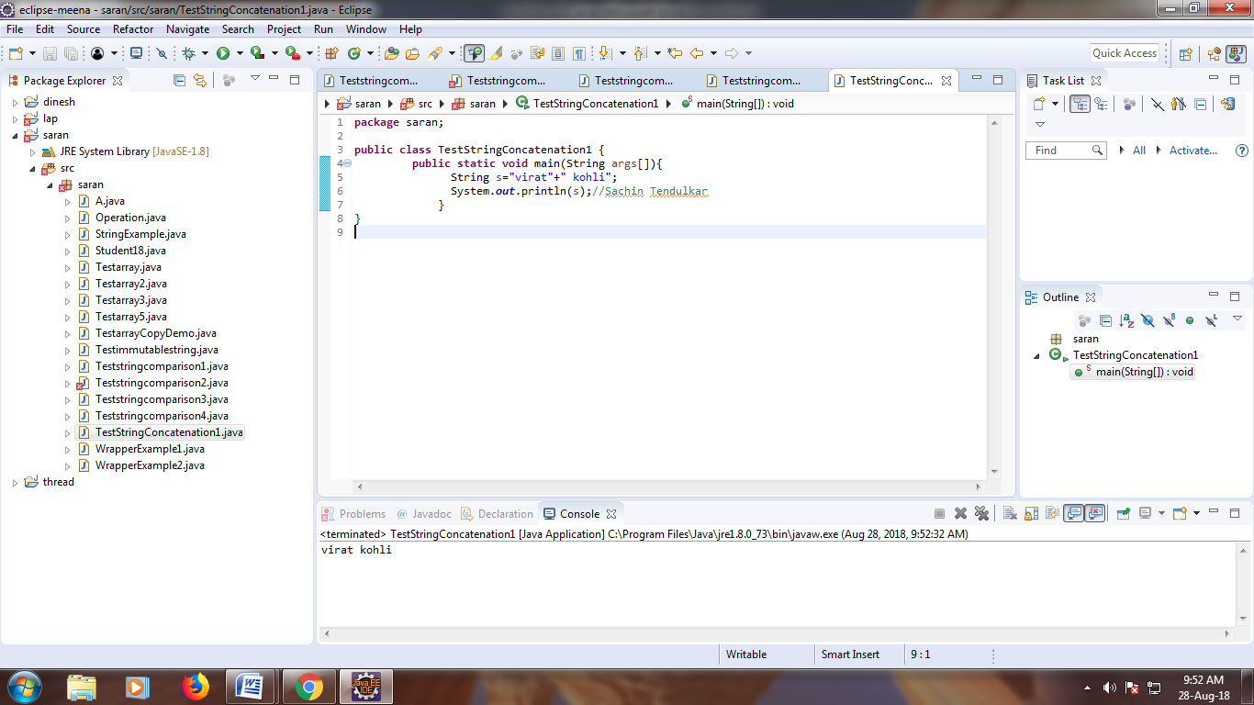

**PROGRAM:**

**package** meena;

**public** **class** TestStringConcatenation3 {

**public** **static** **void** main(String args[]){

String s1="Meenaya ";

String s2="palani";

String s3=s1.concat(s2);

System.***out***.println(s3);//Sachin Tendulkar

}

}

**OUTPUT:**

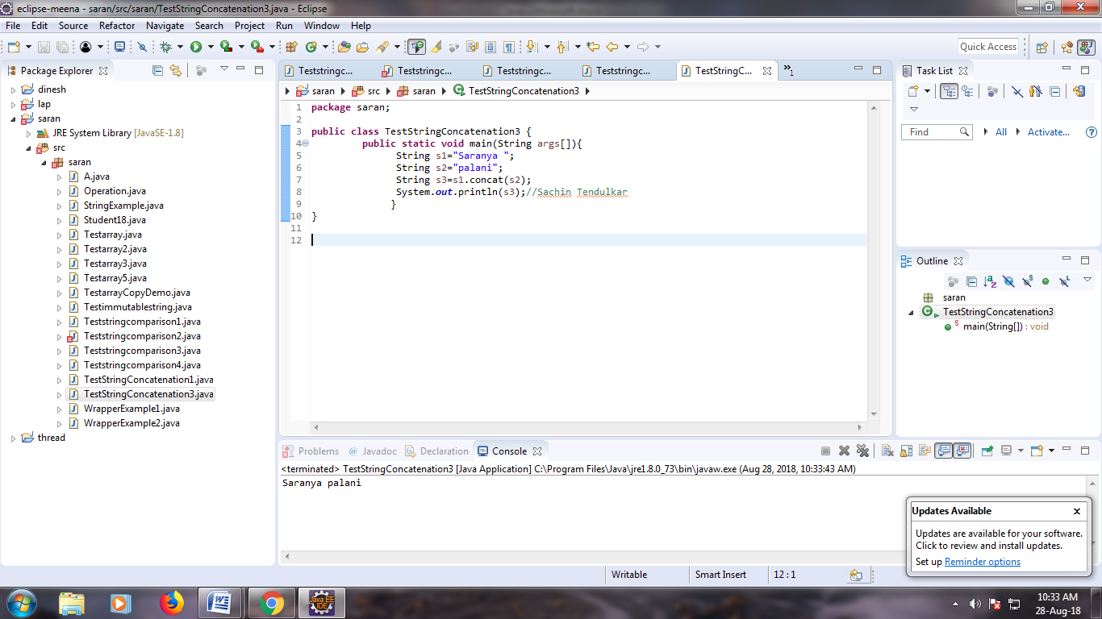

**PROGRAM:**

**package** meena;

**public** **class** TestSubstring {

**public** **static** **void** main(String args[]){

String s="Sachin Tendulkar";

System.***out***.println(s.substring(6));//Tendulkar

System.***out***.println(s.substring(0,6));//Sachin

}

}

**OUTPUT:**

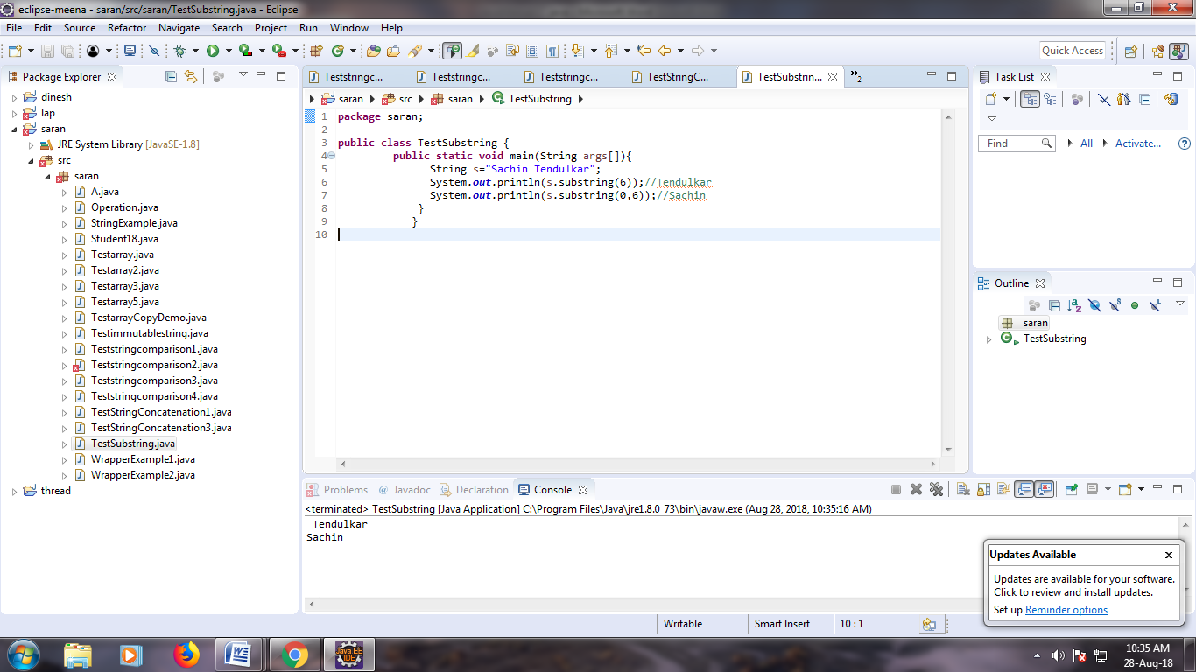

**PROGRAM:**

**package** meena;

**public** **class** Sample {

**public** **static** **void** main(String args[]){

String s="Meenaya";

System.***out***.println(s.toUpperCase());//MEENAYA

System.***out***.println(s.toLowerCase());//meenaya

System.***out***.println(s);//Meenaya(no change in original)

}

}

**OUTPUT:**

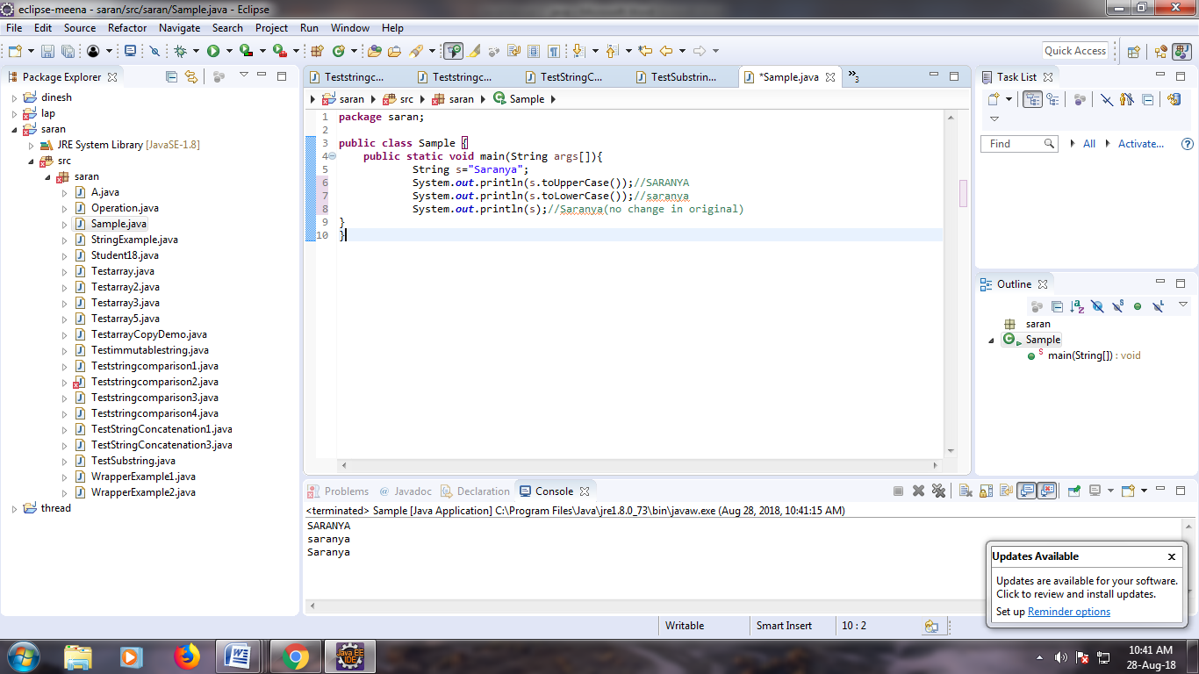

**PROGRAM:**

**package** meena;

**public** **class** Sample {

**public** **static** **void** main(String args[]){

String s=" Meenaya ";

System.***out***.println(s);// Sachin

System.***out***.println(s.trim());//Sachin

}}

**OUTPUT:**

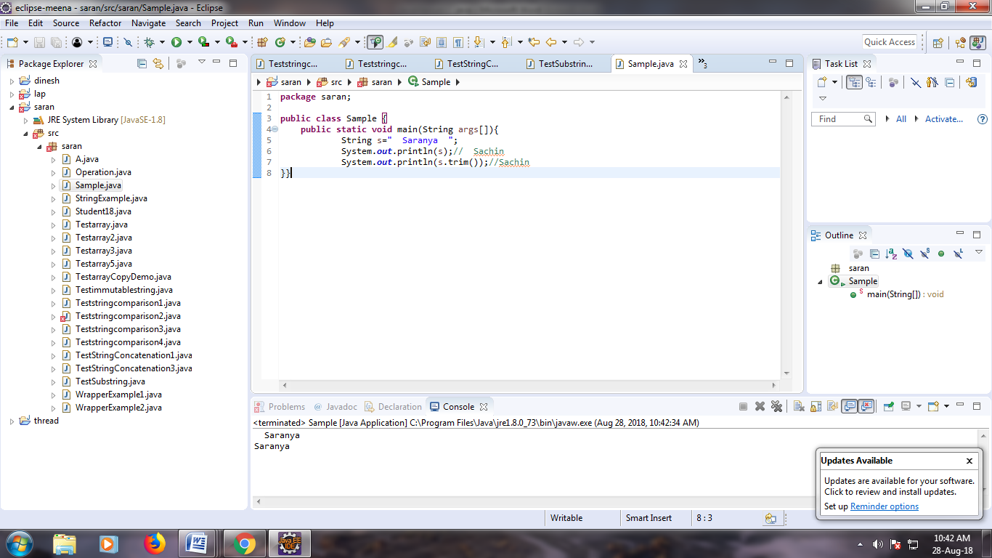

**PROGRAM:**

**package** meena;

**public** **class** Sample {

**public** **static** **void** main(String args[]){

String s="Sachin";

System.***out***.println(s.startsWith("Sa"));//true

System.***out***.println(s.endsWith("n"));//true

}}

**OUTPUT:**

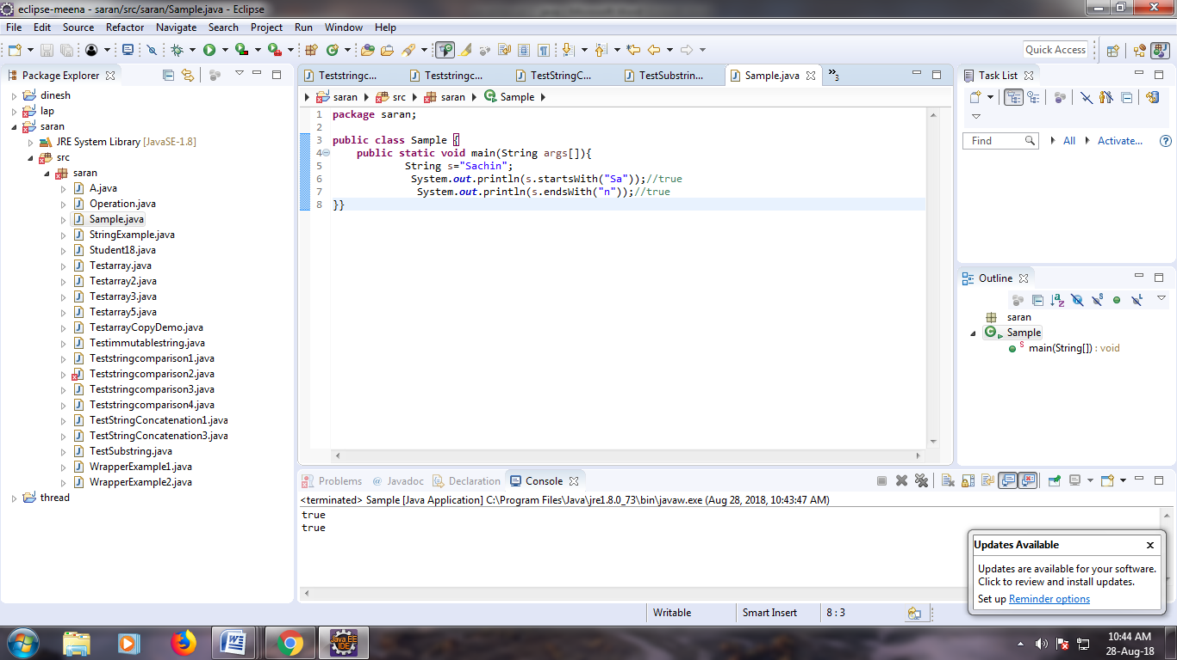

**PROGRAM:**

**package** meena;

**public** **class** Sample1 {

**public** **static** **void** main(String args[]){

String s="Meenaya";

System.***out***.println(s.charAt(0));//S

System.***out***.println(s.charAt(3));//a

}

}

**OUTPUT:**

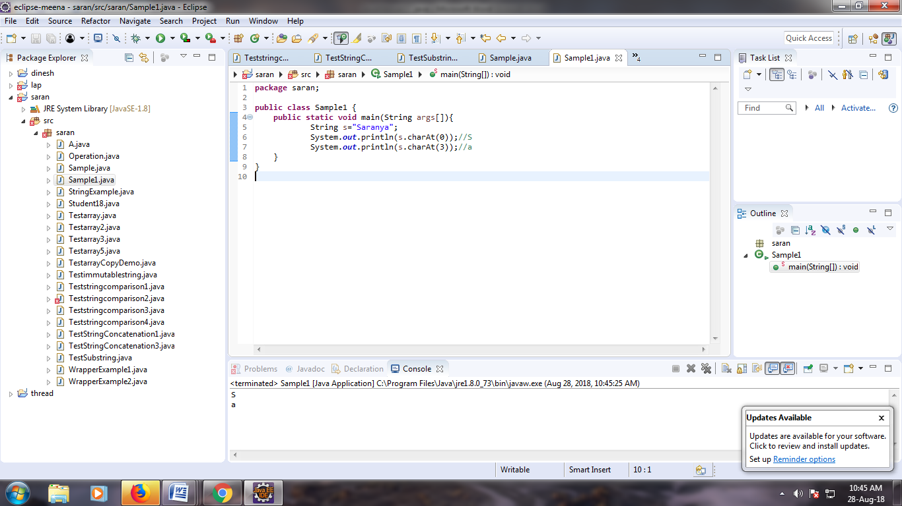

**PROGRAM:**

**package** meena;

**public** **class** Sample2 {

**public** **static** **void** main(String args[]){

String s="Meenaya";

System.***out***.println(s.length());//7

}

}

**OUTPUT:**

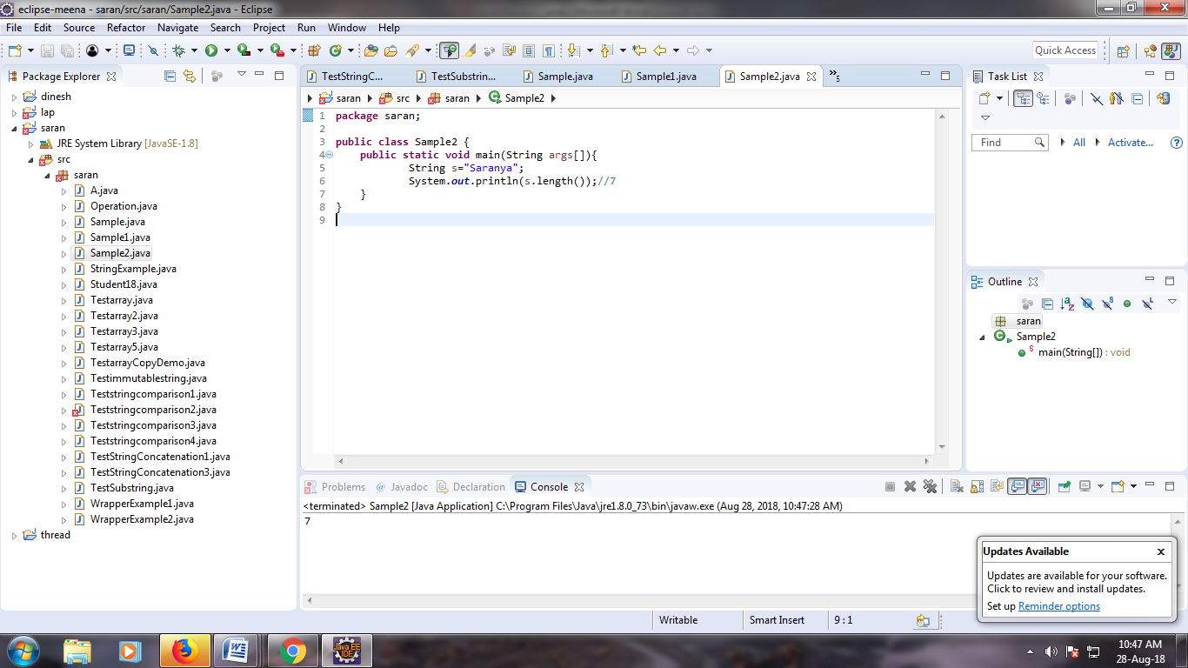

**PROGRAM:**

**package** meena;

**public** **class** Sample3 {

**public** **static** **void** main(String args[]){

String s=**new** String("Meenaya");

String s2=s.intern();

System.***out***.println(s2);//Meenaya

}

}

**OUTPUT:**

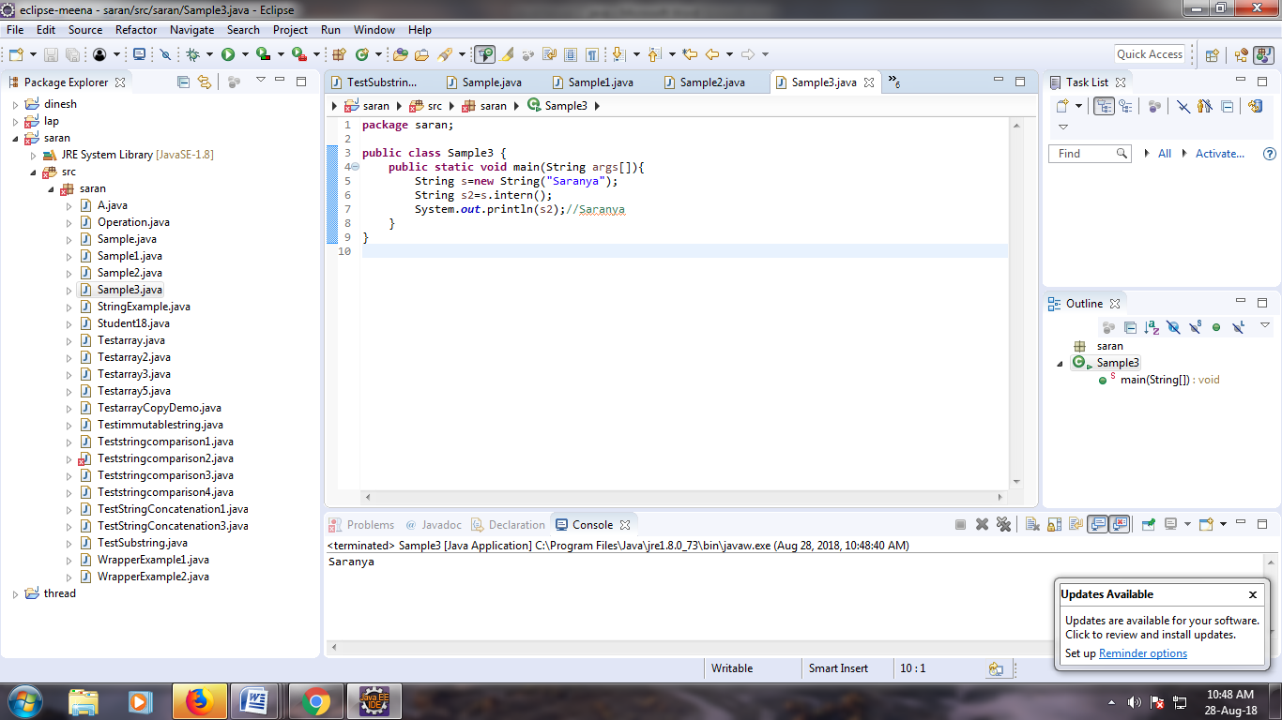

**PROGRAM:**

**package** meena;

**public** **class** Sample3 {

**public** **static** **void** main(String args[]){

String s=**new** String("dhoni");

String s2=s.intern();

System.***out***.println(s2);//dhoni

}

}

**OUTPUT:**

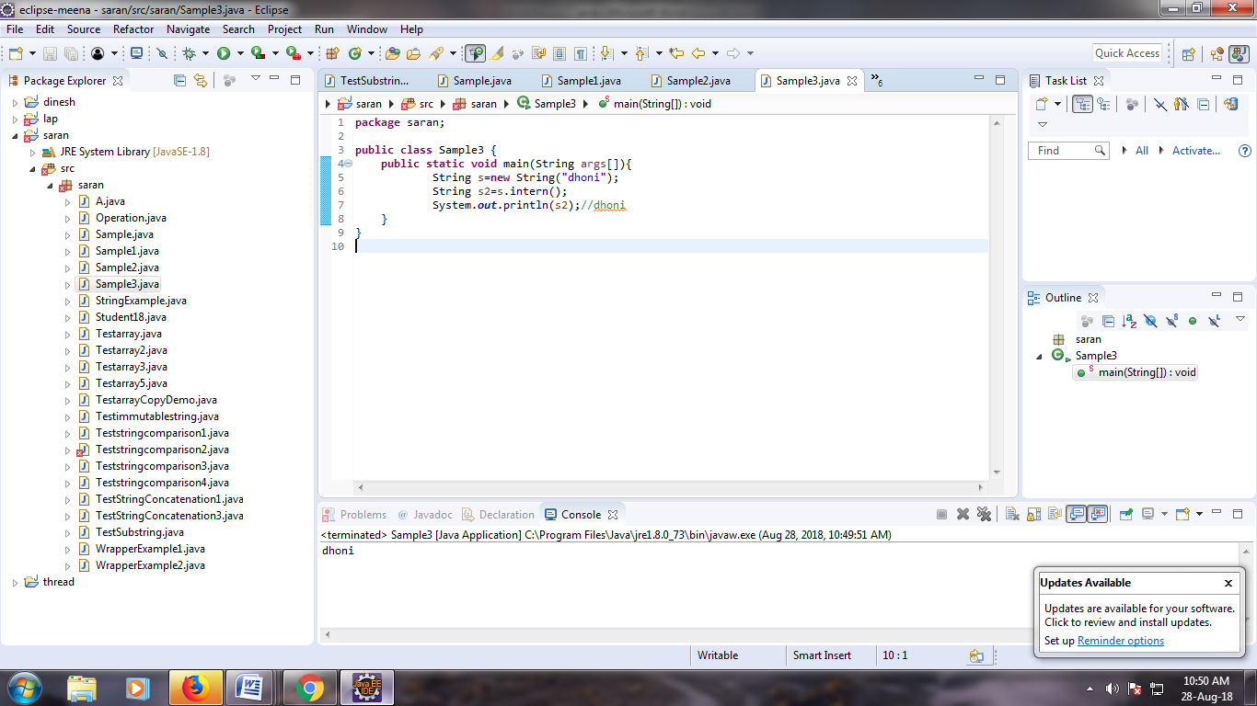

**PROGRAM:**

**package** meena;

**public** **class** Sample3 {

**public** **static** **void** main(String args[]){

**int** a=10;

String s=String.*valueOf*(a);

System.***out***.println(s+10);

}

}

**OUTPUT:**

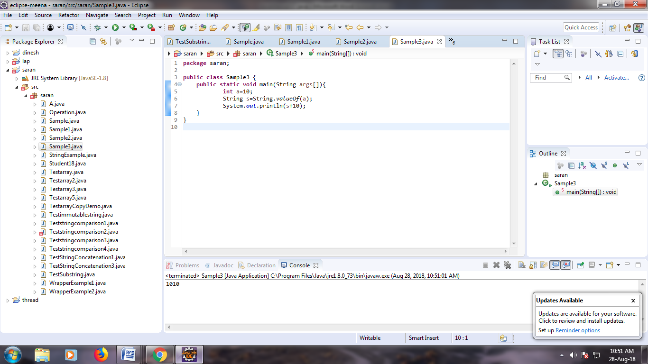

**PROGRAM:**

**package** meena;

**public** **class** Sample3 {

**public** **static** **void** main(String args[]){

String s1="web programming laboratory";

String replaceString=s1.replace("g","s");

System.***out***.println(replaceString);

}

}

**OUTPUT:**

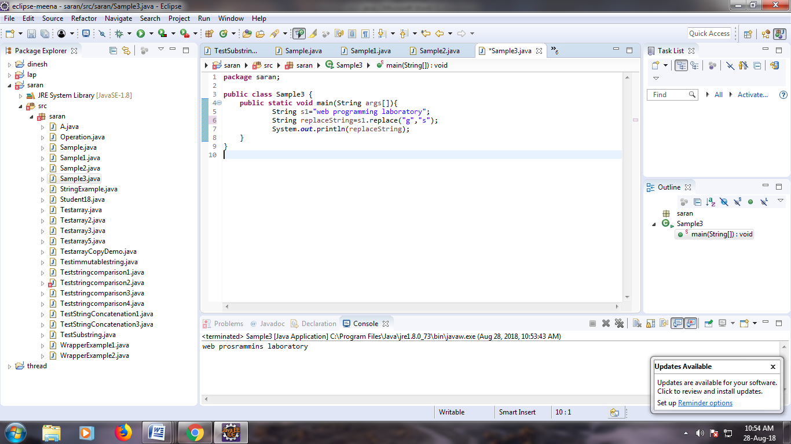

**PROGRAM:**

**package** meena;

**public** **class** B {

**public** **static** **void** main(String args[]){

StringBuffer sb=**new** StringBuffer("Hello ");

sb.append("Java");//now original string is changed

System.***out***.println(sb);//prints Hello Java

}

}

**OUTPUT:**

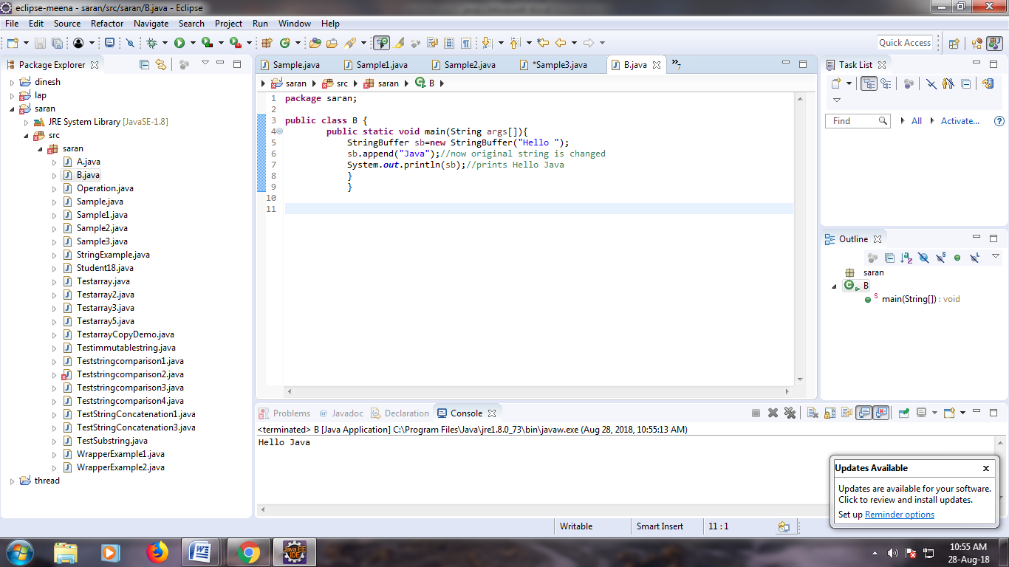

**PROGRAM:**

**package** meena;

**public** **class** B {

**public** **static** **void** main(String args[]){

StringBuffer sb=**new** StringBuffer("Hello ");

sb.insert(1,"Java");//now original string is changed

System.***out***.println(sb);//prints HJavaello

}

}

**OUTPUT:**

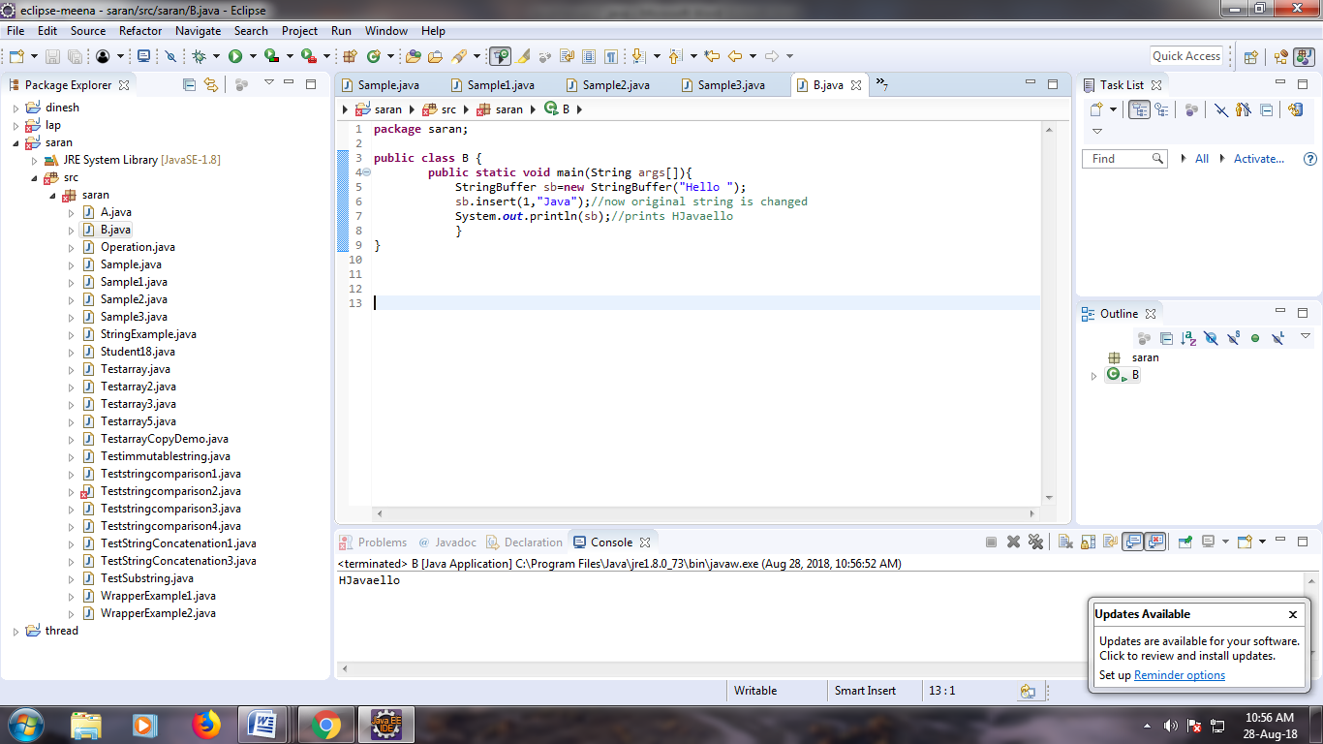

**PROGRAM:**

**package** meena;

**public** **class** B {

**public** **static** **void** main(String args[]){

StringBuffer sb=**new** StringBuffer("Hello");

sb.replace(1,3,"Java");

System.***out***.println(sb);//prints HJavalo

}

}

**OUTPUT:**

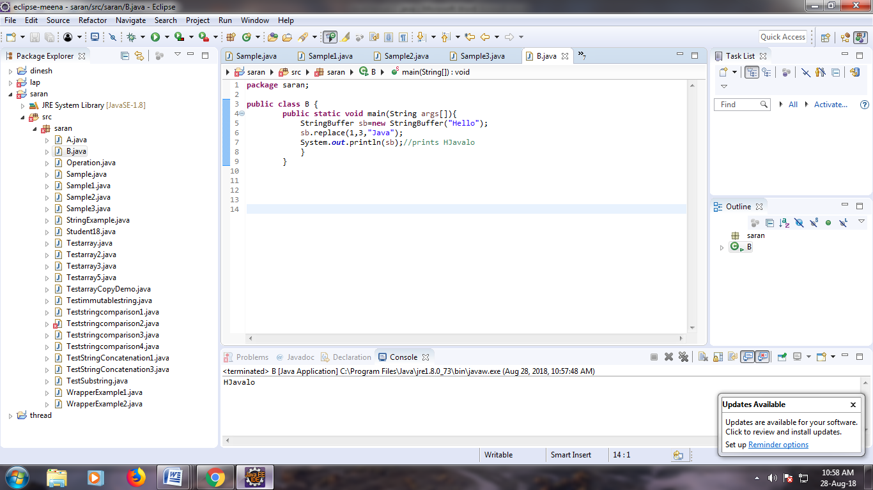

**PROGRAM:**

**package** meena;

**public** **class** B {

**public** **static** **void** main(String args[]){

StringBuffer sb=**new** StringBuffer("Hello");

sb.delete(1,3);

System.***out***.println(sb);//prints Hlo

}

}

**OUTPUT:**

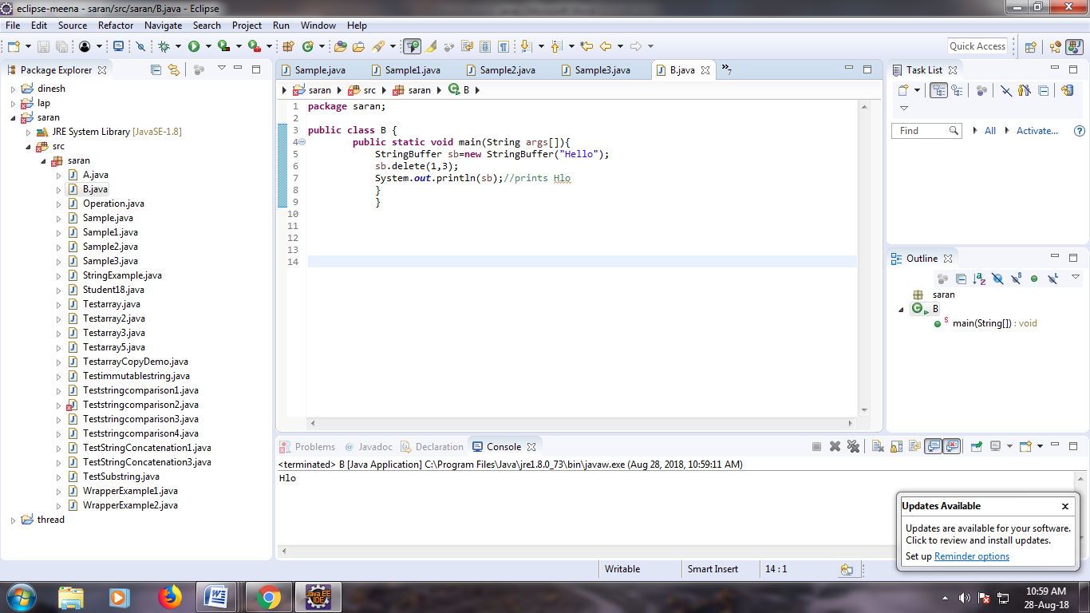

**PROGRAM:**

**package** meena;

**public** **class** B {

**public** **static** **void** main(String args[]){

StringBuffer sb=**new** StringBuffer("meena");

sb.reverse();

System.***out***.println(sb);//prints olleH

}

}

**OUTPUT:**

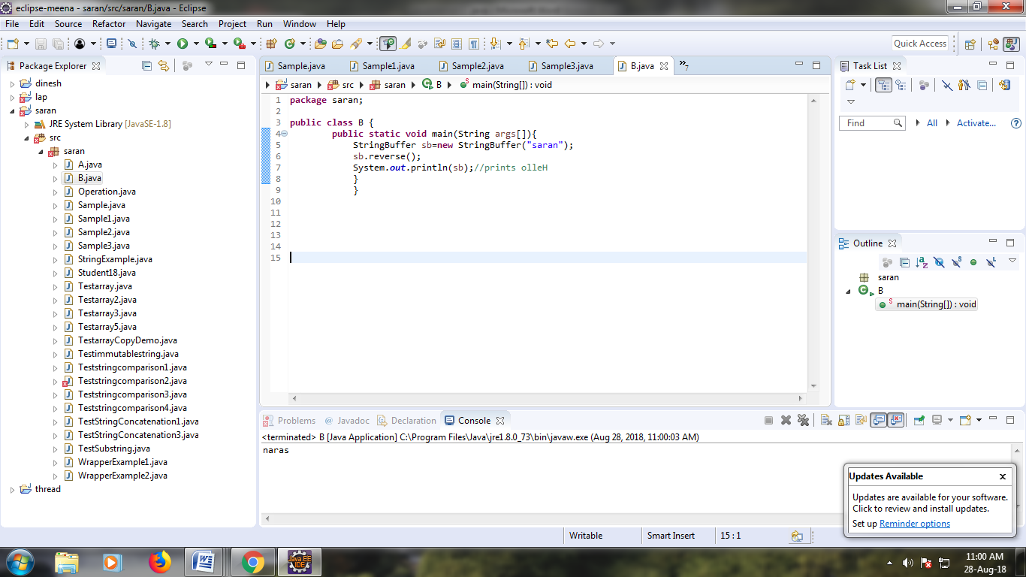

**PROGRAM:**

**package** meena;

**public** **class** B {

**public** **static** **void** main(String args[]){

StringBuffer sb=**new** StringBuffer();

System.***out***.println(sb.capacity());//default 16

sb.append("Hello");

System.***out***.println(sb.capacity());//now 16

sb.append("java is my favourite language");

System.***out***.println(sb.capacity());//now (16*2)+2=34 i.e (oldcapacity*2)+2

}

}

**OUTPUT:**

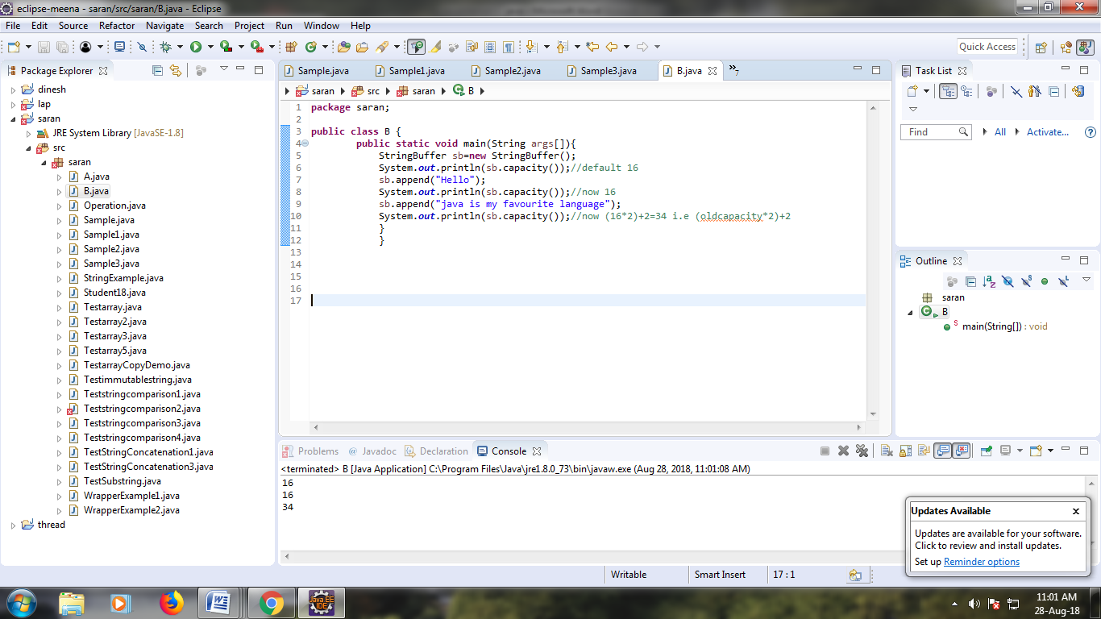

**PROGRAM:**

**package** meena;

**public** **class** B {

**public** **static** **void** main(String args[]){

StringBuffer sb=**new** StringBuffer();

System.***out***.println(sb.capacity());//default 16

sb.append("Hello");

System.***out***.println(sb.capacity());//now 16

sb.append("java is my favourite language");

System.***out***.println(sb.capacity());//now (16*2)+2=34 i.e (oldcapacity*2)+2

sb.ensureCapacity(10);//now no change

System.***out***.println(sb.capacity());//now 34

sb.ensureCapacity(50);//now (34*2)+2

System.***out***.println(sb.capacity());//now 70

}

}

**OUTPUT:**

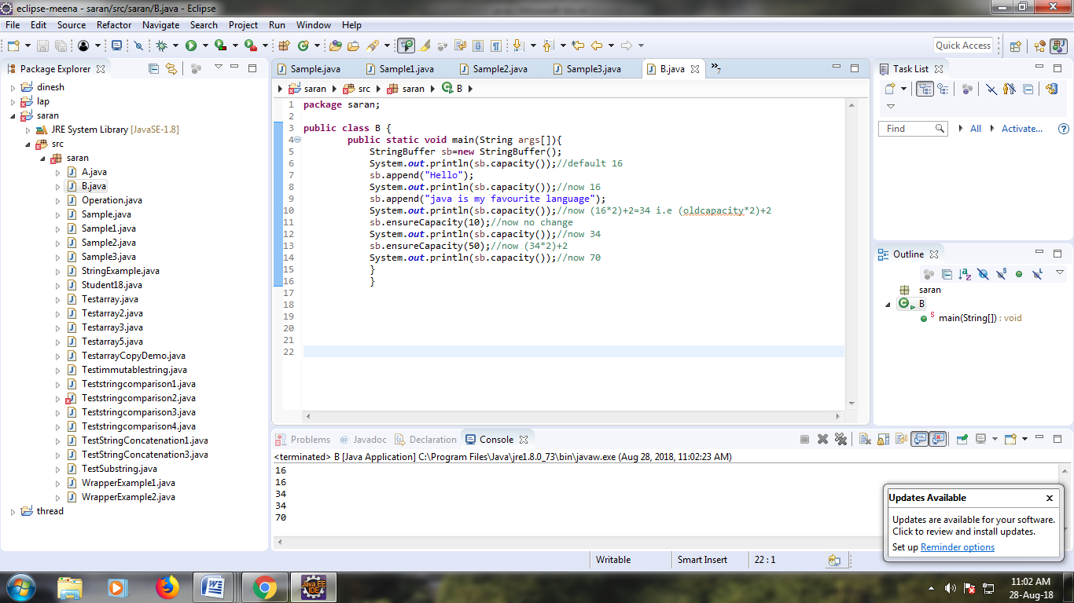

**PROGRAM:**

**package** meena;

**public** **class** Student {

**int** rollno;

String name;

String city;

Student(**int** rollno, String name, String city){

**this**.rollno=rollno;

**this**.name=name;

**this**.city=city;

}

**public** **static** **void** main(String args[]){

Student s1=**new** Student(101,"Raj","lucknow");

Student s2=**new** Student(102,"Vijay","ghaziabad");

System.***out***.println(s1);//compiler writes here s1.toString()

System.***out***.println(s2);//compiler writes here s2.toString()

}

}

**OUTPUT:**

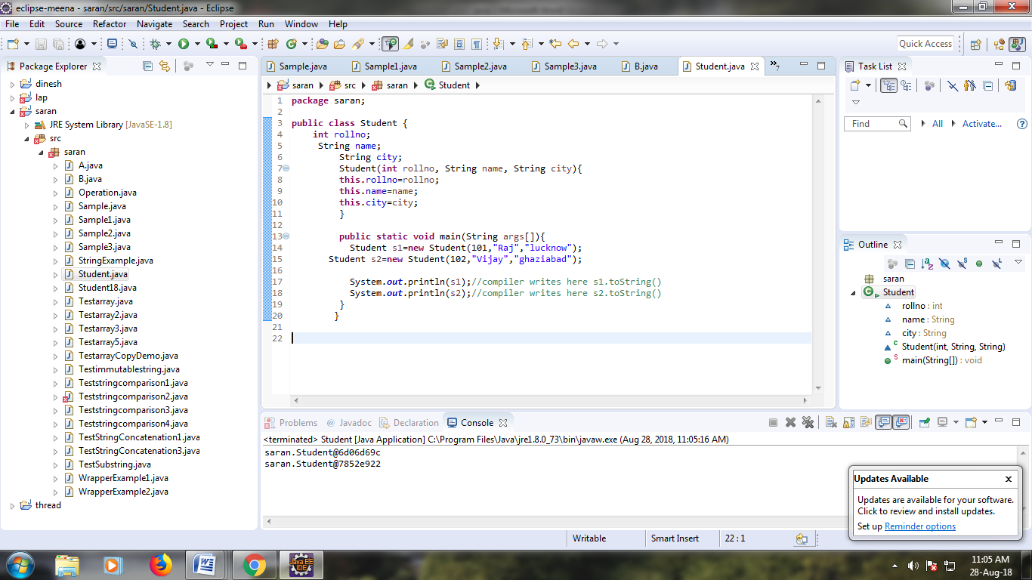

**PROGRAM:**

**package** meena;

**public** **class** Student1 {

**int** rollno;

String name;

String city;

Student1(**int** rollno, String name, String city){

**this**.rollno=rollno;

**this**.name=name;

**this**.city=city;

}

**public** String toString(){//overriding the toString() method

**return** rollno+" "+name+" "+city;

}

**public** **static** **void** main(String args[]){

Student1 s1=**new** Student1(101,"akash","mumbai");

Student1 s2=**new** Student1(102,"ajith","uttar pradesh");

System.***out***.println(s1);//compiler writes here s1.toString()

System.***out***.println(s2);//compiler writes here s2.toString()

}

}

**OUTPUT:**

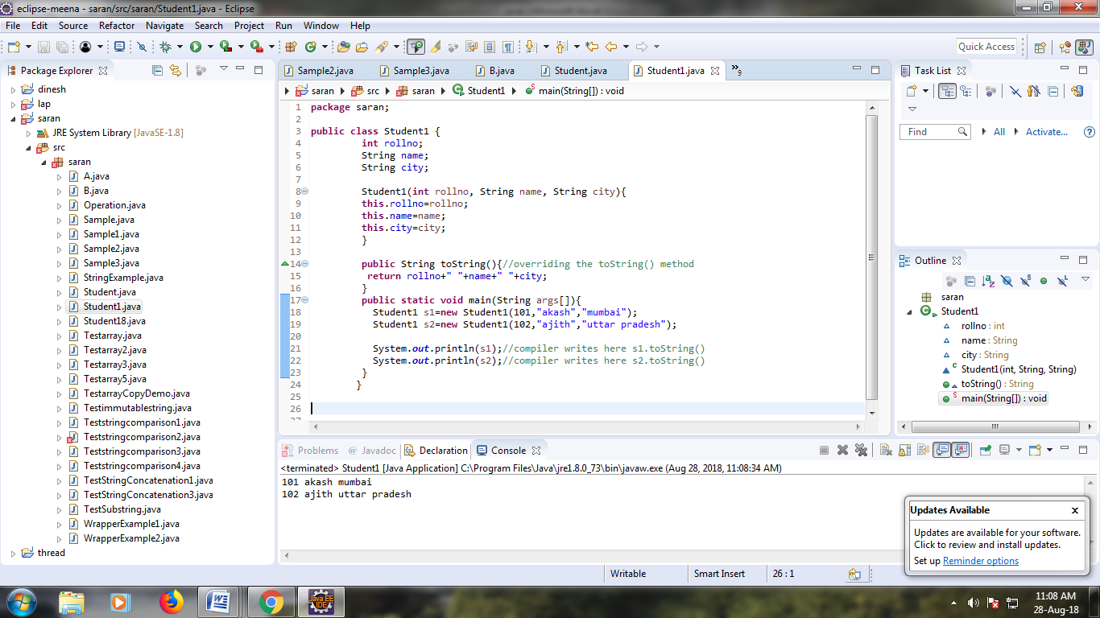

**PROGRAM:**

**package** meena;

**import** java.util.StringTokenizer;

**public** **class** Simple{

**public** **static** **void** main(String args[]){

StringTokenizer st = **new** StringTokenizer("my name is meena"," ");

**while** (st.hasMoreTokens()) {

System.***out***.println(st.nextToken());

}

}

}

**OUTPUT:**

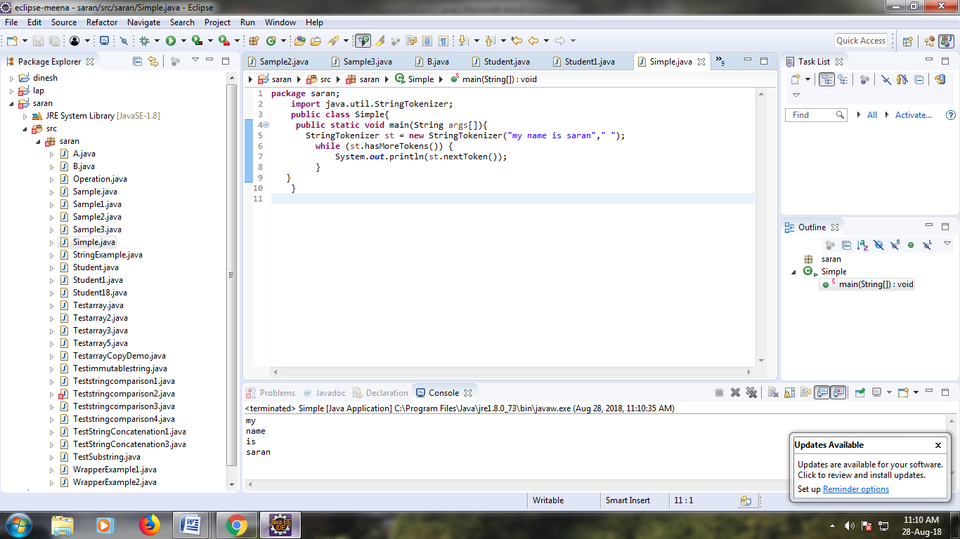

**PROGRAM:**

**package** meena;

**import** java.util.regex.*;

**public** **class** RegexExample1{

**public** **static** **void** main(String args[]){

//1st way

Pattern p = Pattern.*compile*(".s");//. represents single character

Matcher m = p.matcher("as");

**boolean** b = m.matches();

//2nd way

**boolean** b2=Pattern.*compile*(".s").matcher("as").matches();

//3rd way

**boolean** b3 = Pattern.*matches*(".s", "as");

System.***out***.println(b+" "+b2+" "+b3);

}}

**OUTPUT:**

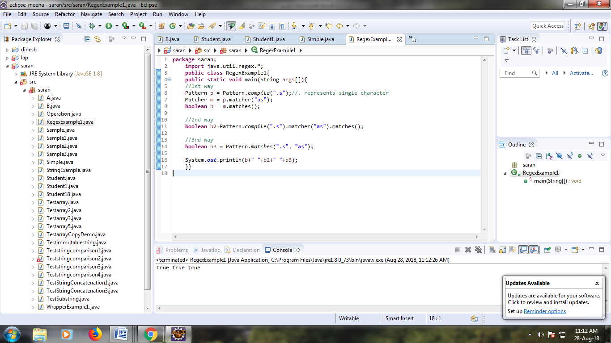

**PROGRAM:**

**package** meena;

**import** java.util.regex.*;

**class** RegexExample2{

**public** **static** **void** main(String args[]){

System.***out***.println(Pattern.*matches*(".s", "as"));//true (2nd char is s)

System.***out***.println(Pattern.*matches*(".s", "mk"));//false (2nd char is not s)

System.***out***.println(Pattern.*matches*(".s", "mst"));//false (has more than 2 char)

System.***out***.println(Pattern.*matches*(".s", "amms"));//false (has more than 2 char)

System.***out***.println(Pattern.*matches*("..s", "mas"));//true (3rd char is s)

}}

**OUTPUT:**

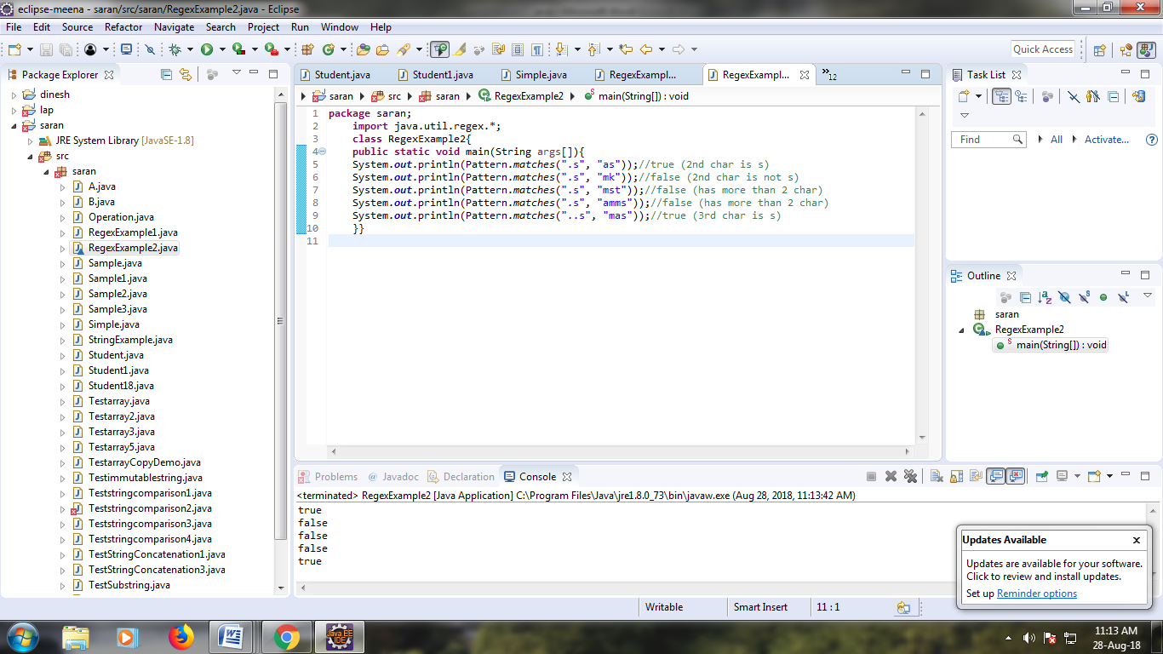

**PROGRAM:**

**package** meena;

**import** java.util.regex.*;

**class** RegexExample3{

**public** **static** **void** main(String args[]){

System.***out***.println(Pattern.*matches*("[amn]", "abcd"));//false (not a or m or n)

System.***out***.println(Pattern.*matches*("[amn]", "a"));//true (among a or m or n)

System.***out***.println(Pattern.*matches*("[amn]", "ammmna"));//false (m and a comes more than once)

}}

**OUTPUT:**

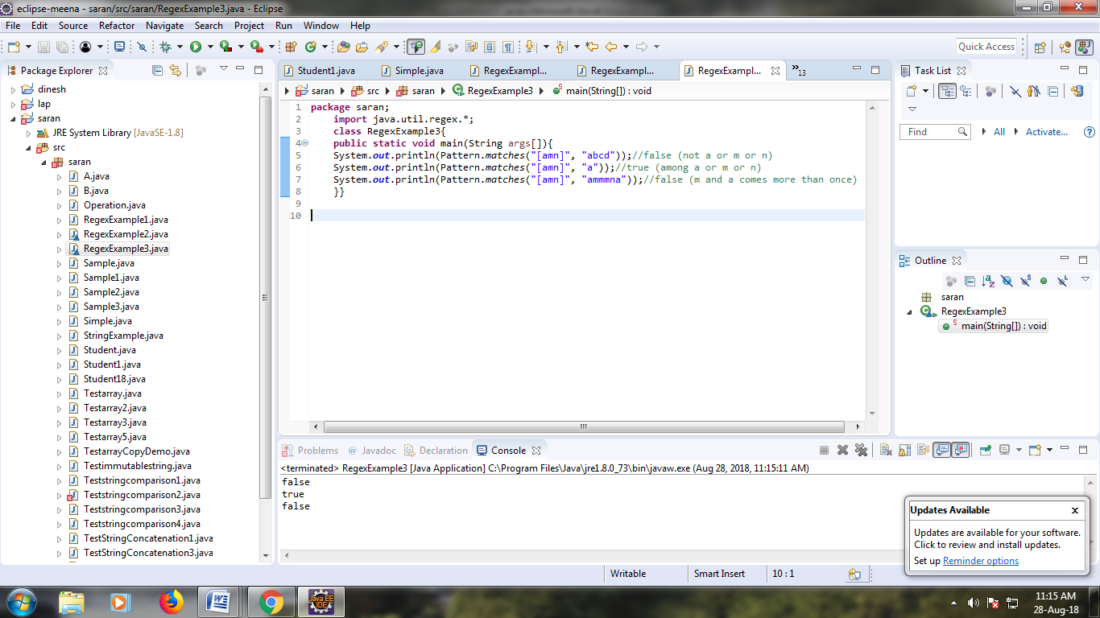

**PROGRAM:**

**package** meena;

**import** java.util.regex.*;

**class** RegexExample4{

**public** **static** **void** main(String args[]){

System.***out***.println("? quantifier ....");

System.***out***.println(Pattern.*matches*("[amn]?", "a"));//true (a or m or n comes one time)

System.***out***.println(Pattern.*matches*("[amn]?", "aaa"));//false (a comes more than one time)

System.***out***.println(Pattern.*matches*("[amn]?", "aammmnn"));//false (a m and n comes more than one time)

System.***out***.println(Pattern.*matches*("[amn]?", "aazzta"));//false (a comes more than one time)

System.***out***.println(Pattern.*matches*("[amn]?", "am"));//false (a or m or n must come one time)

System.***out***.println("+ quantifier ....");

System.***out***.println(Pattern.*matches*("[amn]+", "a"));//true (a or m or n once or more times)

System.***out***.println(Pattern.*matches*("[amn]+", "aaa"));//true (a comes more than one time)

System.***out***.println(Pattern.*matches*("[amn]+", "aammmnn"));//true (a or m or n comes more than once)

System.***out***.println(Pattern.*matches*("[amn]+", "aazzta"));//false (z and t are not matching pattern)

System.***out***.println("* quantifier ....");

System.***out***.println(Pattern.*matches*("[amn]*", "ammmna"));//true (a or m or n may come zero or more times)

}}

**OUTPUT:**

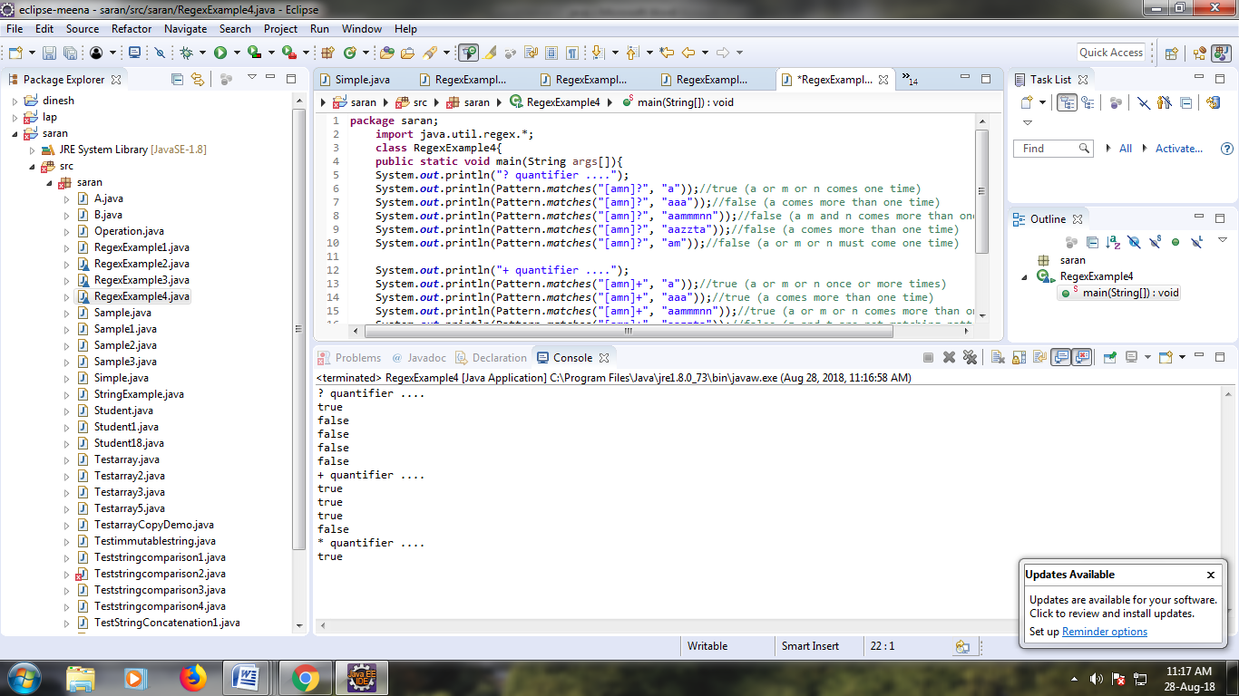

**PROGRAM:**

**package** meena;

**import** java.util.regex.*;

**class** RegexExample5{

**public** **static** **void** main(String args[]){

System.***out***.println("metacharacters d....");

System.***out***.println(Pattern.*matches*("\\d", "abc"));//false (non-digit)

System.***out***.println(Pattern.*matches*("\\d", "1"));//true (digit and comes once)

System.***out***.println(Pattern.*matches*("\\d", "4443"));//false (digit but comes more than once)

System.***out***.println(Pattern.*matches*("\\d", "323abc"));//false (digit and char)

System.***out***.println("metacharacters D....");

System.***out***.println(Pattern.*matches*("\\D", "abc"));//false (non-digit but comes more than once)

System.***out***.println(Pattern.*matches*("\\D", "1"));//false (digit)

System.***out***.println(Pattern.*matches*("\\D", "4443"));//false (digit)

System.***out***.println(Pattern.*matches*("\\D", "323abc"));//false (digit and char)

System.***out***.println(Pattern.*matches*("\\D", "m"));//true (non-digit and comes once)

System.***out***.println("metacharacters D with quantifier....");

System.***out***.println(Pattern.*matches*("\\D*", "mak"));//true (non-digit and may come 0 or more times)

}}

**OUTPUT:**

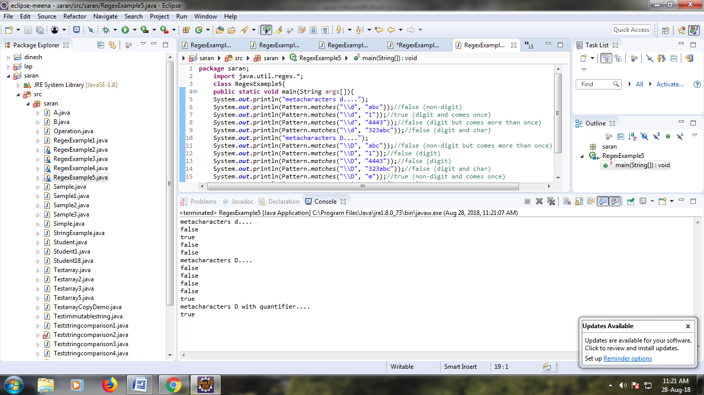

**PROGRAM:**

**package** meena;

**import** java.util.regex.*;

**class** RegexExample6{

**public** **static** **void** main(String args[]){

System.***out***.println(Pattern.*matches*("[a-zA-Z0-9]{6}", "arun32"));//true

System.***out***.println(Pattern.*matches*("[a-zA-Z0-9]{6}", "kkvarun32"));//false (more than 6 char)

System.***out***.println(Pattern.*matches*("[a-zA-Z0-9]{6}", "JA2Uk2"));//true

System.***out***.println(Pattern.*matches*("[a-zA-Z0-9]{6}", "arun$2"));//false ($ is not matched)

}}

**OUTPUT:**

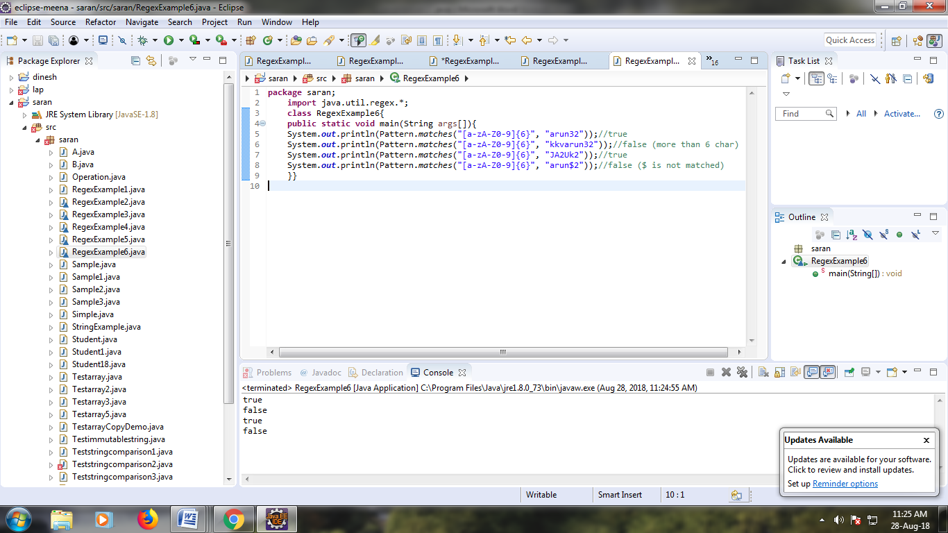

**PROGRAM:**

**package** meena;

**import** java.util.regex.*;

**class** RegexExample7{

**public** **static** **void** main(String args[]){

System.***out***.println("by character classes and quantifiers ...");

System.***out***.println(Pattern.*matches*("[789]{1}[0-9]{9}", "9953038949"));//true

System.***out***.println(Pattern.*matches*("[789][0-9]{9}", "9953038949"));//true

System.***out***.println(Pattern.*matches*("[789][0-9]{9}", "99530389490"));//false (11 characters)

System.***out***.println(Pattern.*matches*("[789][0-9]{9}", "6953038949"));//false (starts from 6)

System.***out***.println(Pattern.*matches*("[789][0-9]{9}", "8853038949"));//true

System.***out***.println("by metacharacters ...");

System.***out***.println(Pattern.*matches*("[789]{1}\\d{9}", "8853038949"));//true

System.***out***.println(Pattern.*matches*("[789]{1}\\d{9}", "3853038949"));//false (starts from 3)

}}

**OUTPUT:**

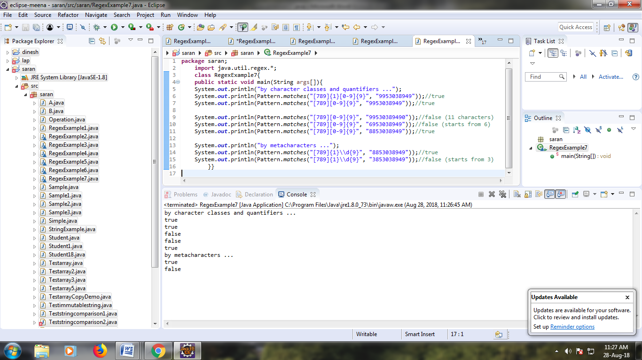

**PROGRAM:**

**package** meena;

**public** **class** Testtrycatch2 {

**public** **static** **void** main(String args[]){

**try**{

**int** data=50/0;

}**catch**(ArithmeticException e){System.***out***.println(e);}

System.***out***.println("rest of the code...");

}

}

**OUTPUT:**

